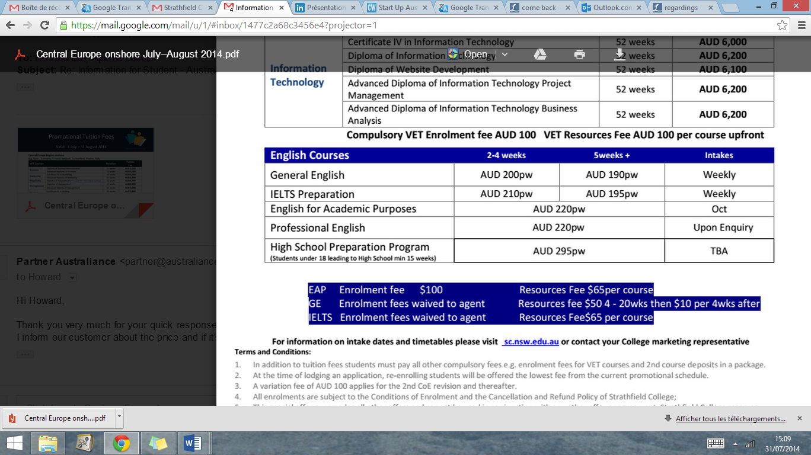

AUSTRALIANCE

Community Manager & Digital Marketing

6-months Internship   
**Sydney**

Available from December 2014

More information:

[hr@australiance.com](mailto:hr@australiance.com) [www.australiance.com/recruitment](http://www.australiance.com/recruitment)

After 4 years of activity and experience Australiance wants to grow and take its activities to the next level. A good step for you to learn all about the Australian job market, to start your career on the Kangaroos’ island! In addition you will get proven ability leading eCommerce website and optimizing customer engagement across digital platforms.

**Duration**: 6 months  
**Location**: Sydney, city center  
**Salary**: 250$/month  
**Position**: **Web Communication Ninja, Digital Marketer**

Australiance, part of PmC Group, is a growing business launched in  
Sydney 4 years ago. Behind two websites [www.](http://www.Australiance.com)a[ustraliance.com](http://www.Australiance.com) & [www.](http://www.Australiance.fr)a[ustraliance.fr](http://www.Australiance.fr) PmC Group has for main activity to help international professionals, students and small businesses to settle in Australia.

**Key missions:**

* Develop articles, how-to videos and execute content marketing campaign to increase online conversion rate.
* Manage and promote Australiance’s offers & events
* Contributes to development, implementation and ongoing optimization of community strategies (mainly on LinkedIn and Facebook)

As Communication Ninja you will also be in charge to create advertisement, newsletters, articles… to promote Australiance’s services, partners, events…  
With the main objective to manage relations with customers to build the Australiance’s community.

As Digital Marketer in a small business environment you will work on several different projects from web (UX/UI) design, advertising campaigns. Reporting and interpreting analytics and using these insights to form decision-making and drive strong ROI.

English: fluent   
Italian/Spanish: a strength

Photoshop and Video maker software.  
MailChimp campaigns

Good Writing skills in French

Project management a must

Entrepreneurial spirit.  
Fast learner, highly motivated.

Strong communication skills. Desire to take initiative and challenge yourself

Behaviour

Experience

Requirements and  
key Skills

IT

Language

Send us your resume at [hr@australiance.com](mailto:hr@australiance.com)